RACE NOTICE

Fundrace 2020

Sunday 12 January 2020

Kanata Nordiq, Nepean ON

XC Chelsea Masters and Kanata Nordiq are proud to invite you to Fundrace 2020.

This will be the 6th edition of this event!
Fundrace 2020 is held to raise funds to support the local ski community and elite Junior ski racers from the National Capital area who are bound to the World Championships.
XC Chelsea Masters and Kanata Nordiq have committed to award 100% of all proceeds from the event.

The 2020 World Junior and U23 Championships will be held in Oberwiesenthal, Germany, 28 Feb – 8 Mar 2020. And just to go there, our Canadian athletes must pay $3,500 prior to departure from Canada.
This is why our XC community is raising funds while fun racing for them!
It all started in winter 2013, with both the 2013 and 2014 edition of the Masters For Juniors Time Trial being held in the Gatineau Park. Team sprints were introduced with the 2015 edition of M4J, held at Nakkertok South when we raised $3600. In 2018, Fundrace got its new name, and moved to Chelsea Nordiq at Centre Meredith. Last year, Skinouk agreed to co-host what was our most successful Fundrace to date, raising $5,000! This year, following the spirit of rotating collaboration within the community, Fundrace is moving to another major local ski club, Kanata Nordiq.
See xcchelseamasters.com/pastFundraces/ for details on past events.

Hosted By: XC Chelsea Masters and Kanata Nordiq
http://xcchelseamasters.com
http://www.kanatanordic.ca/

Event Location: Kanata Nordiq ski club
411 Corkstown Rd, Nepean, ON K2K 2Y1
(entrance on hill at red flag)

Event Official Schedule:

Time | Activity
08:30 – 09:00 | Bib pick-up
09:15 – 09:45 | Women
09:45 – 10:15 | Men
10:15 – 10:45 | Mixed Gender
11:15 – 11:45 | Awards
11:45 | Closure
The organizing committee reserves the right to change the schedule.

Race Committee:
Chief of Event | Francois Dubrous
Chief of Competition | Trevor Plestid
Chief of Course and Stadium | Dan Mallett
Chief of Operations | Francois Dubrous
Chief of Volunteers | Emily Heath

Parking: On site

Contact Info: Trevor at trevor@plestid.com, or François at fr.dubrous@gmail.com

Event Info: http://xcchelseamasters.com/Fundrace-2020/
https://www.facebook.com/events (search for Fundrace)

Registration: Registration will be accepted on-line through zone4 until midnight on Friday 10 January 2020. There will be no registration on-site.
https://zone4.ca (search for Fundrace)

Registration fee: $30 per person or $50 as a team (2 persons).
No refund will be issued, except if the event is cancelled
Please remember that 100% of all gross proceeds from the event will be awarded to athletes.

Cancellation: In case of event cancellation, you may choose to donate your entry fees to Fundrace. Check the appropriate box during registration.
Otherwise refunds will be issued minus the processing fees incurred.

Race Kit Package: Pick-up at Kanata Nordiq ski club.

Age: The event is open to skiers age 8+ years old as of December 31, 2019.

Course Length: Approximately 0.8 km.

Seeding: Self seeding.

Race Format: Two Person Team Sprints
All Sprints are skate technique.
Mass start format.

The first skier races a lap of the course and then tags their teammate, who skis a lap of the course before tagging back their teammate. Each teammate skis three laps of the course for a total of six laps per team.

Each Team will be entered in the age category of the oldest team member.

NCD Categories: All NCD categories are available for registration: Register in the men, women, or mixed gender categories.

Your year of birth (YOB) will be used to register you for the appropriate NCD category.

Teams with multiple category ages will have results calculated based on the YOB of the oldest skier.

NCD points will be awarded. Categories are:

▪ U8 1/2 (ages 6/7)  ▪ U10 1/2 (ages 8/9)  ▪ U12 1/2 (ages 10/11)  ▪ U14 1/2 (ages 12/13)  ▪ U16 (ages 14/15) | ▪ U18 (ages 16/17)  ▪ U20 (ages 18/19)  ▪ Senior (ages 20/29)  ▪ Masters (30+)
Age as of December 31st, 2019.
Waxing: Athletes, clubs and coaches will use only low-fluoro or non-fluoro glide waxes. We trust that this will be effectively self-governed.

With Support from:

0
300m

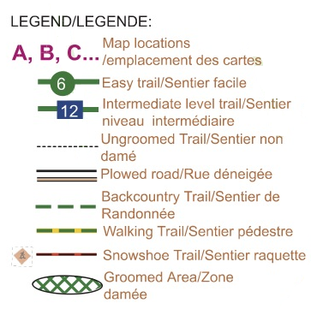
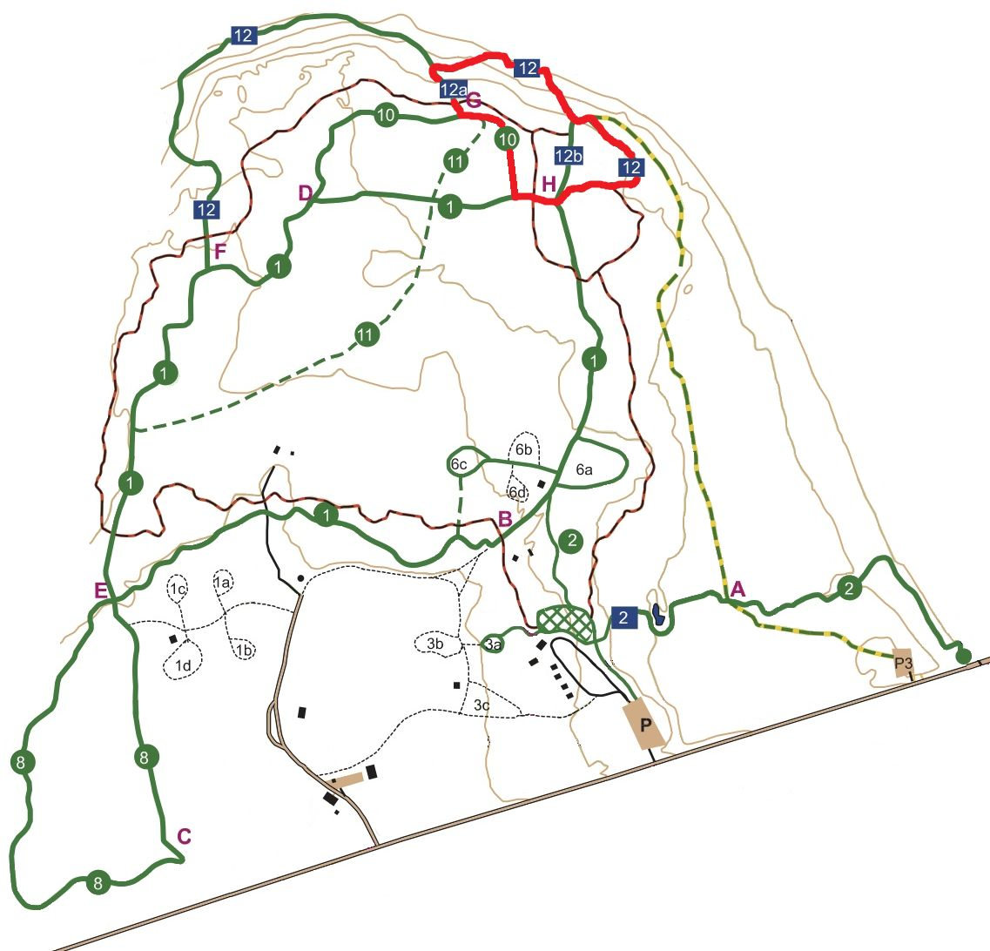
STADIUM
Ski & walk to
Stadium ~750 m
Entrance
Corkstown Road
Drop off

Parking
Race Centre

